US Army Corps of Engineers
Afghanistan Engineer District

AED Design Requirements:
Superelevation Road Design

Various Locations, Afghanistan

MARCH 2009

TABLE OF CONTENTS

AED DESIGN REQUIREMENTS FOR
SUPERELEVATION ROAD DESIGN VARIOUS LOCATIONS, AFGHANISTAN

Section Page

1. General 1

2. Superelevation 1

3. Superelevation Transition 1

4. Superelevation Transition Placement 2

5. Traveled Way Widening 2

6. Stopping Sight Distance 4

7. Passing Sight Distance 5

8. Design Considerations 5

9. As-Builts 5

Tables

Table 1. Minimum Radii for Design Superelevation Rates, Design Speed 1 and ℮max=10%

Table 2. Maximum Relative Gradients 2

Table 3. Calculated and Design Values for Travel Way Widening 3

Table 4. Adjustments for Traveled Way Widening Values 3

Table 5. Stopping Sight Distance 4

Exhibits

Exhibit 1. Components for Determining Horizontal Sight Distance 4

1. General

The purpose of this document is to provide requirements to Contractors for any project requiring the design and construction of superelevation road design.

2. Superelevation

Superelevation of a road is required to offset the centripetal acceleration that acts toward the center of curvature on a horizontal curve. For paved roads the rate of superelevation (℮) is a function of the radius of curvature (R) of the road and the vehicle speed (V). The Islamic Republic of Afghanistan, Ministry of Public Works, Interim Road and Highway Standards, paragraph IX (c) limits the maximum superelevation rate (℮max) for all roads is 10%. Table 1 shown below will be used to determine the superelevation rates for horizontal curves of a known radius, a known vehicles speed and a maximum superelevation rate of
10%. If a horizontal curve has a sufficiently large radius and low vehicle speed so that no ℮ is identified on Table 1, no superelevation is required for the curve. Additionally the minimum radius of a curve can be obtained by the vehicle speed and the maximum ℮.

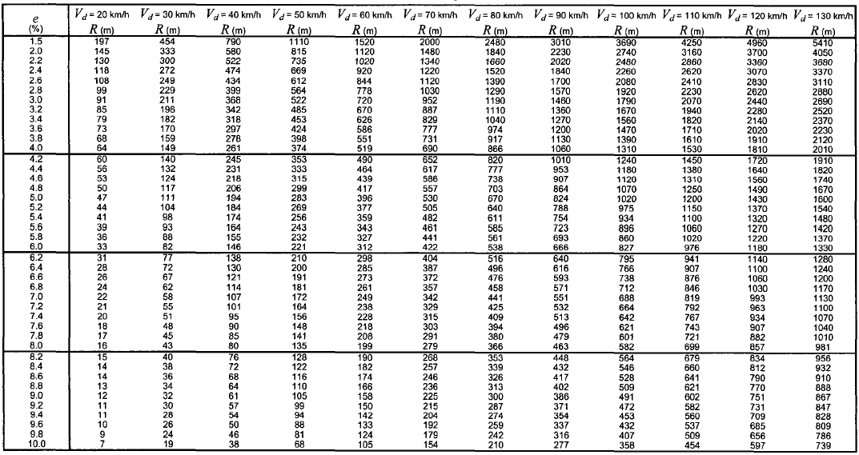Table 1. Minimum Radii for Design Superelevation Rates, Design Speed and ℮max=10%

3. Superelevation Transition

A fully superelevated road section is obtained using a superelevation transition (T) from the normal crown of the road. The superelevation transition is composed of a superelevation runoff (Lr) and tangent runout (Lt). The superelevation runoff is the length of the roadway required to change the outside (superelevated) lane cross slope from a flat cross slope (0%) to a fully superelevated section. The length of the superelevation runoff is obtained from Equation 1 as shown below:

Equation 1 Lr=[((w*n1)*℮d)*bw]/∆

Where:

Lr=minimum length of superelevation runoff (m)
w=width of one traffic lane (m)
n1=number of lanes rotated
℮d=design superelevation rate (%)

bw=adjustment factor for number of lanes rotated=[1+0.5(n1-1)]/n1
∆=maximum relative gradient (%) from Table 2

Table 2. Maximum Relative Gradients
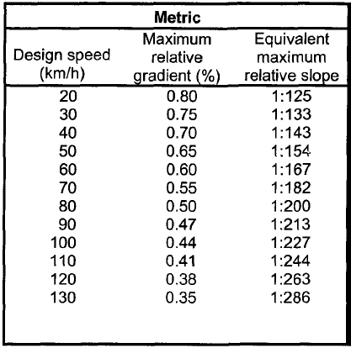

The tangent runout is the length of the roadway required to change the outside (superelevated) lanes from a normal cross crown cross slope to a flat cross slope (0%). The length of the tangent runout is obtained from equation 2 as shown below:

Equation 2 Lt=(℮NC/℮d)Lr

Where:

Lt=minimum length of tangent runout (m)
℮NC=normal cross slope rate (%)
℮d=design superelevation rate (%)
Lr=minimum length of superelevation runoff (m)

4. Superelevation Transition Placement

The proper placement of the superelevation transition (superelevation runoff and tangent runout) in relationship to the beginning of the curve (PC) or end of curve (PT) may have an effect of the safety and driver comfort along the curve. The placement of the superelevation runoff shall be with 1/3 of the runoff length on the curve and 2/3 of the runoff length on the tangent. The tangent runout will be immediately prior to the superelevation runoff when entering a curve and immediately after the superelevation runoff when exiting a curve.

5. Traveled Way Widening

Traveled way widening for horizontal curves may be required to make the operating conditions on the curve similar to those on the tangents. The traveled way widening values for two-lane highway with the specified roadway widths, curve radii and a WB-15 truck are obtained from Table 3 shown below.

Table 3. Calculated and Design Values for Travel Way Widening
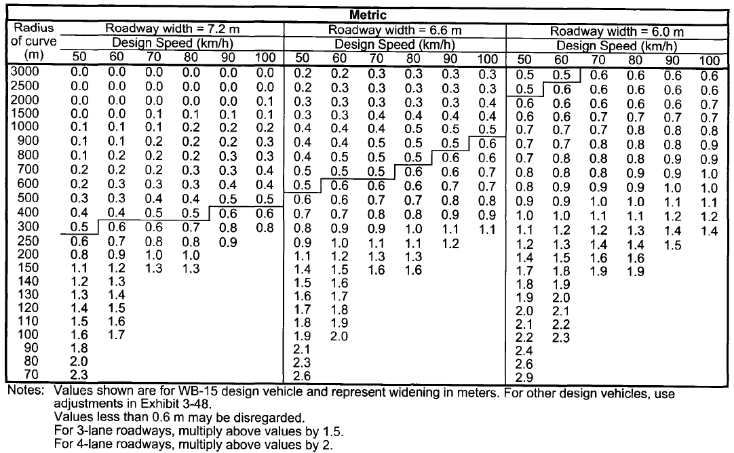

Travel lane widening for alternative vehicle types can be obtained by adding the values defined in Table 4 for the appropriate curve radius and vehicle type to the value obtained from Table 3.

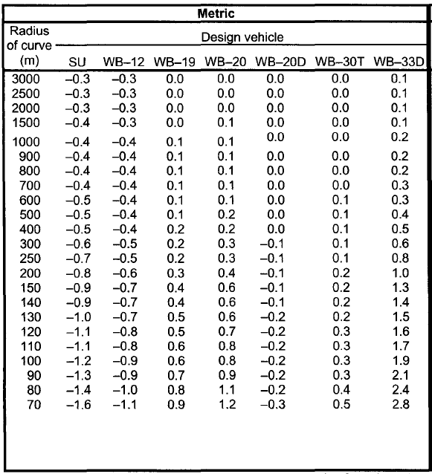Table 4. Adjustments for Traveled Way Widening Values

Very little benefit is gained from small amount of widening. Therefore the minimum widening will be 0.6 meters with widening amounts less than 0.6 meters being disregarded. Widening should be applied on the inside edge of the curve only and the widening should transition over the superelevation runoff length with 2/3 of the transition length along the tangent and 1/3 of the transition length along the curve. The edge of the traveled way through the widening transition should be a smooth curve with the transition ends avoiding an angular break at the pavement edge.

6. Stopping Sight Distance

Required stopping sight distance for various design speeds is presented in Table 5. The horizontal sightline offset in meters from the center of the inside travel lane is obtained from Equation 3 as shown in Exhibit 1.

Table 5. Stopping Sight Distance
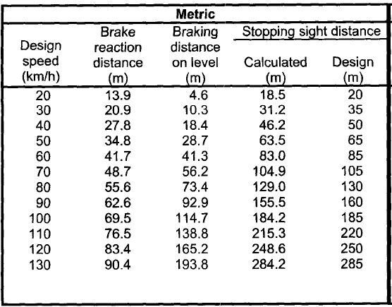

Exhibit 1. Components for Determining Horizontal Sight Distance
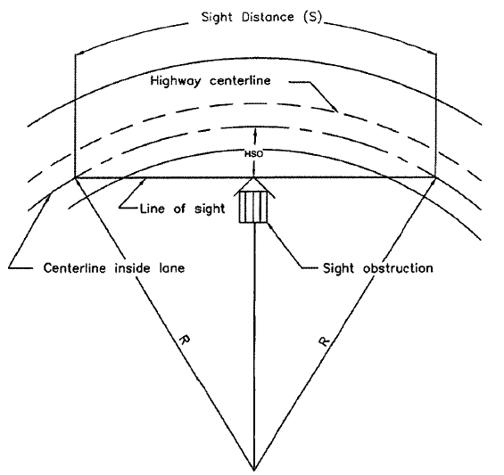

Equation 3 HSO=R[1-cos(28.65S/R)]

Where:

HSO=horizontal sightline offset (m) S=stopping sight distance (m) R=radius of curve (m)

Where sufficient stopping sight distance is not available due to sight obstructions, alternative designs such as increasing the offset to the obstruction, increasing the radius or reducing the design speed should be considered for safety and economic reasons. The selected alternative should not include
shoulder widths on the inside of the curve in excess of 3.6 meters to eliminate the chance of drivers using the shoulder as a passing or travel lane.

7. Passing Sight Distance

The minimum passing sight distance for a two-lane road is approximately four times as great as the minimum stopping sight distance at the same design speed. This greater distance may result is the sight line extending beyond the normal road right-of-way. For these reasons, passing sight distance should be limited to tangents and very flat curves.

8. Design Considerations

The following design considerations, in addition to the criteria listed above, should be reviewed for all horizontal curves to endure a safe design.

For a given design speed the minimum radius of curvature for that speed should be avoided wherever practical. The designer should attempt to use the largest radius possible saving the minimum radius curves for the most critical conditions.

Sudden sharp curves should not be introduces at the end of a long tangent section or large radius

curves. curves.
Where a sharp curve is necessary, it should be preceded by a series of successively sharper

For small deflection angles, curves should be sufficiently long to avoid the appearance of a kink. The minimum length for a horizontal curve on a main highway should be three times the design speed in km/h.

Compound curves should be avoided wherever possible. If the use of compound curves is unavoidable the radius of the flatter curve should not be more than 50 percent greater than the radius of the sharper curve.

Reverse curves should be avoided. The distance between reverse curves should be the sum of the superelevation runoff lengths and the tangent runout lengths.

Short tangent sections of roadway between two curves in the same direction should be avoided except where very unusual topographic or fight-of-way conditions make other alternatives impractical. A single large radius curve or two curves of smaller radius resulting is a longer tangent section should be investigates.

9. As-Builts

Upon completion of construction of the roadway, The Contractor shall submit editable CAD format As- Built drawings. The drawing shall show the final product as it was installed in the field, with the exact dimensions, locations, materials used and any other changes made to the original drawings. Refer to Contract Sections 01335 and 01780A of the specific project for additional details.

